# Emergency Light Testing Procedures

**Purpose**

The purpose of this procedure is to test the emergency lights and to check the escape routes are illuminated in event of main power failure. The company has a duty of care under the Health and Safety at Work Act 1974.

**Scope**

The scope covers how to test the emergency lighting under a simulated power failure, and all bodies involve in making sure the lights are okay.

**Responsibilities**

* It is the responsibility of the appointed fire marshals to check and keep records of testing of emergency lighting up to date. Using the log book that will be attached with this procedure.
* In the case of a faulty emergency light, marshals must inform the office manager via email or in person. Its recommended to use email for record purpose.
* It’s the duty of the office manager to arrange agents/electricians to fix faulting lights as soon as possible.

**Procedures of Testing Emergency Lights**

The following procedure shall be followed in other to test the emergency lights.

1. Go up to the light switch panel for a particular room or zone where the emergency light switch is located as shown.

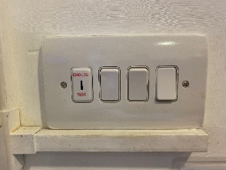

* Insert the key on the test point as shown below:

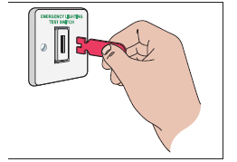

* The lights other than the emergency lights will go off and the emergency lights should come on.
* Visually judge if the lights are okay or not, please remember to keep record of your observations.
* Repeat the same procedure for all the switch board.
* Finally, inform the office manager of any fault findings.

**Emergency Light Building Map**

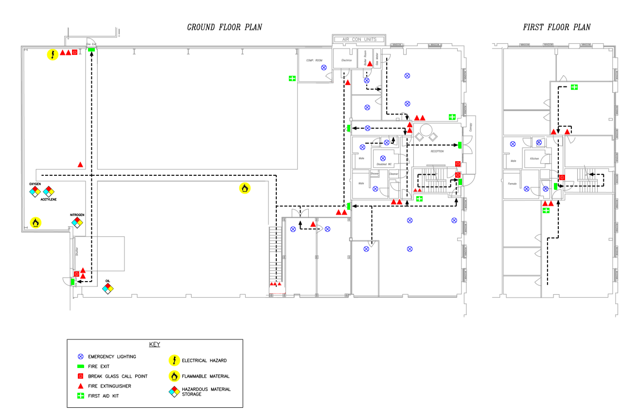

*Note: this image will be update as soon as all the EL (emergency lights) are confirmed.*